# **Lab: Configuring and Monitoring Ports and Protocols**

## **Overview**

The network mapping tool Nmap is an open source, command line utility commonly used in network discovery (“enumeration” in offensive terms), security auditing, and pentesting. Nmap can audit whether ports are open or closed on a target host.

Today you will perform basic scanning operations in Nmap. You’ll also be configuring your DNS server to change the destination of a given domain.

## **Resources**

* [Nmap Manual](https://nmap.org/book/man.html)
* [Nmap Cheat Sheet](https://www.comparitech.com/net-admin/nmap-nessus-cheat-sheet/)
  + [Nmap Cheat Sheet PDF](https://cdn.comparitech.com/wp-content/uploads/2019/06/Nmap-Cheat-Sheet.pdf)

## **Requirements**

### **Part 1: Preparing a Network Environment and Staging Kali Linux**

**IMPORTANT: Restrict the scope of your scans to hosts that are on your own network or targets that you have permission to scan.**

First, prepare a suitable network environment by placing 2-3 different hosts together, either on the the same Host-only network with a pfSense router, or on the same NAT Network (without a pfSense router.

* Ideally, choose VMs with different OSs and/or different configurations (such as a Windows 10 host, an Ubuntu Server, and a pfSense router).
* These will be your targets today.

Use the Kali Linux Virtual Machine you built on Lab 01, and place it on the same network.

Kali Linux comes bundled with Nmap already installed, and can be accessed by using the **nmap** command in Kali’s terminal.

### **Part 2: Port Scanning with Nmap**

Let’s get some practice using Nmap by performing a series of scans (described below).

For each scan:

* ~~Output the results of the command into a file.~~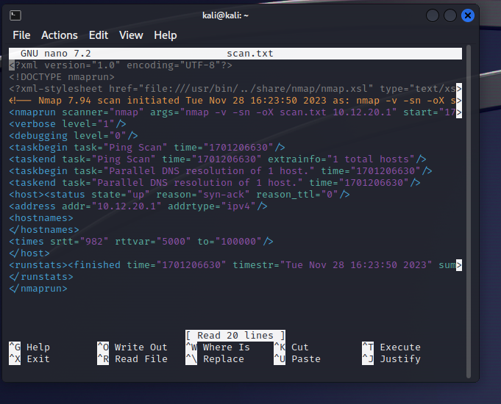
* ~~2 of 38~~
* ~~Include in your lab write-up:~~
  + ~~A screenshot of the output of the command.~~
    - ~~Hint: Use the~~ **~~cat~~** ~~command to print the contents of a file to the terminal, or open the file in Kali’s built-in text editor.~~
  + ~~The exact command you used.~~
    - Nmap -v -sn -oX scan.txt 10.12.20.1
* ~~Answer the following questions:~~
  + What does this scan do in technical terms?
    - In technical terms, this scan is a ping scan designed to identify live hosts in the specified network (10.12.20.1).
  + Was the scan correct?
    - Yes
  + Why/why not?
    - This is my pfsense, I verified the IP address prior to pinging it. So I knew it was valid and currently “UP”
  + Why would you perform this particular scan?
    - This is an advanced version of ping. If I was having success with pings, but still not able to connect to a host, using this command and a few others would help figure out why.

On the local network shared by Kali and your target VMs:

* ~~Perform a scan to discover all hosts on , without scanning any ports.~~

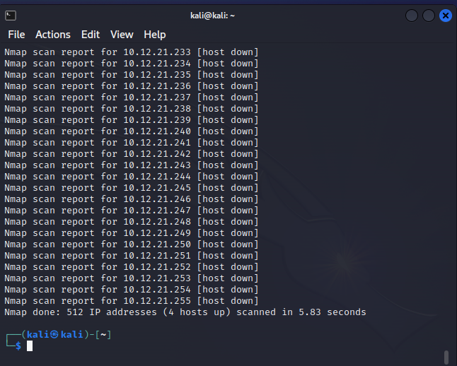

* + In this case, I just did a scan nmap -v -sn -oX scan1.txt 10.12.20.1/23 (Seemed like the easiest way)
  + I saved my results.
* ~~Perform a fast, aggressive scan of the network.~~

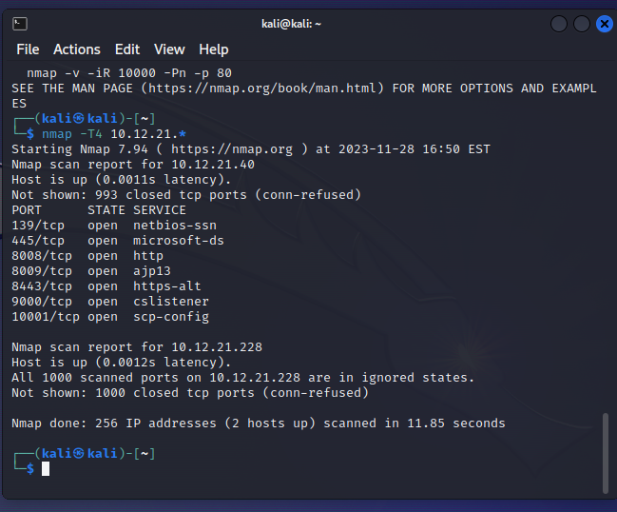

* ~~Scan the 1000 most common ports on each host on the network.~~
  + First Host (pfsense) 10.12.20.1

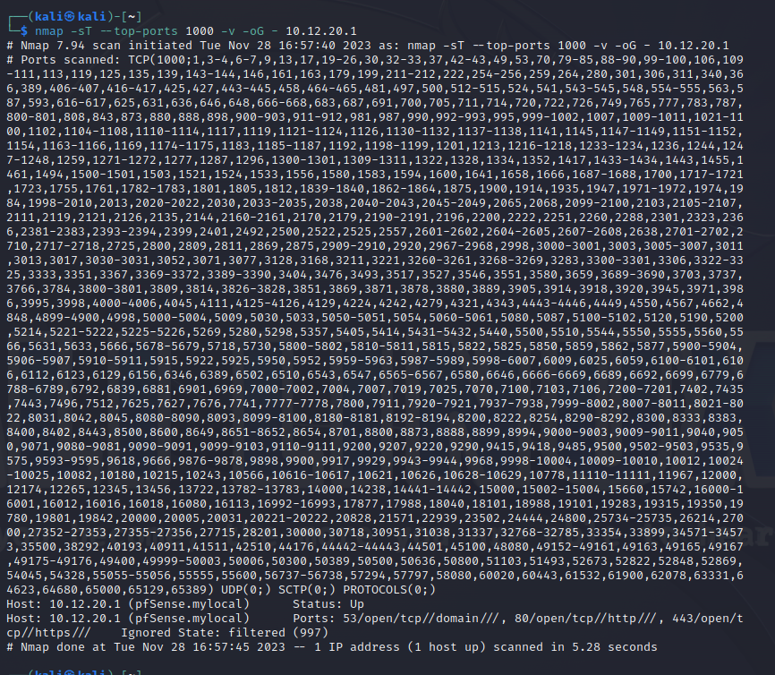

* + Second Host (Windows) 10.12.21.40

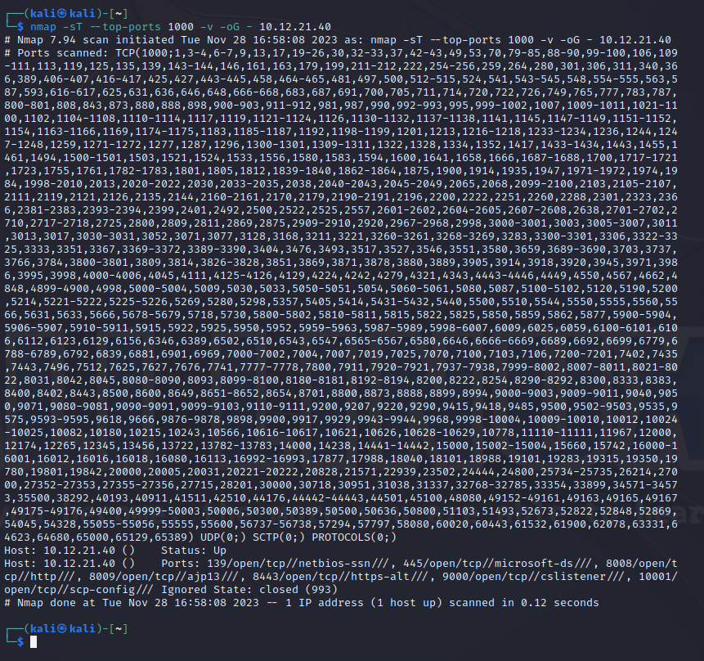

* + Third Host (proxmox) 10.12.20.200

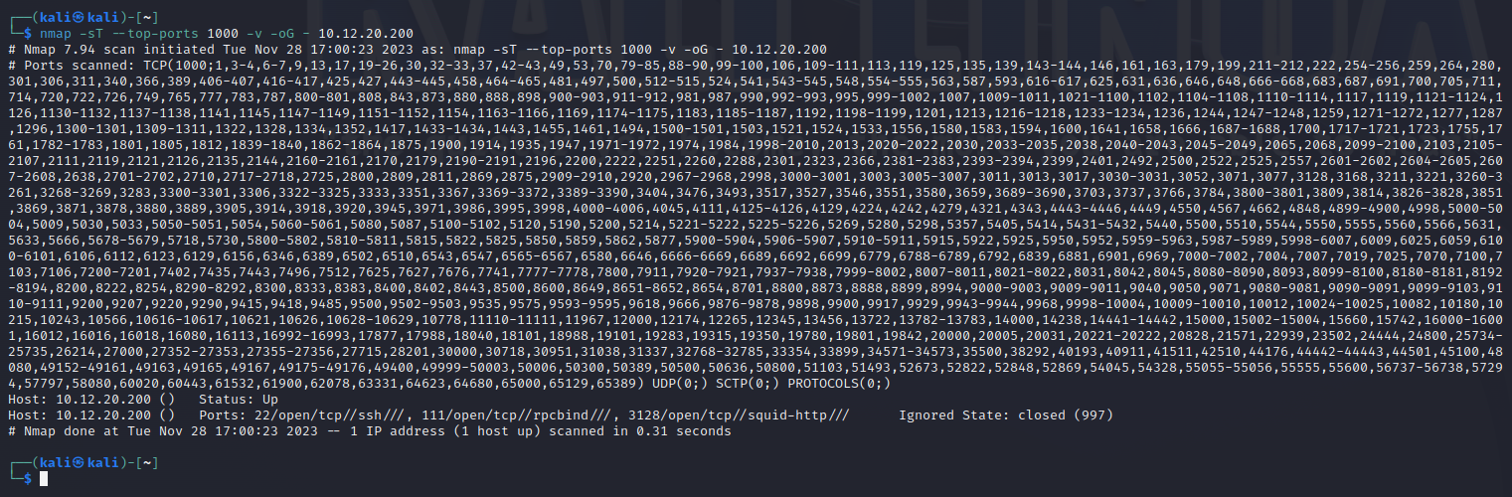

* + Fourth Host (Kali) 10.12.21.228

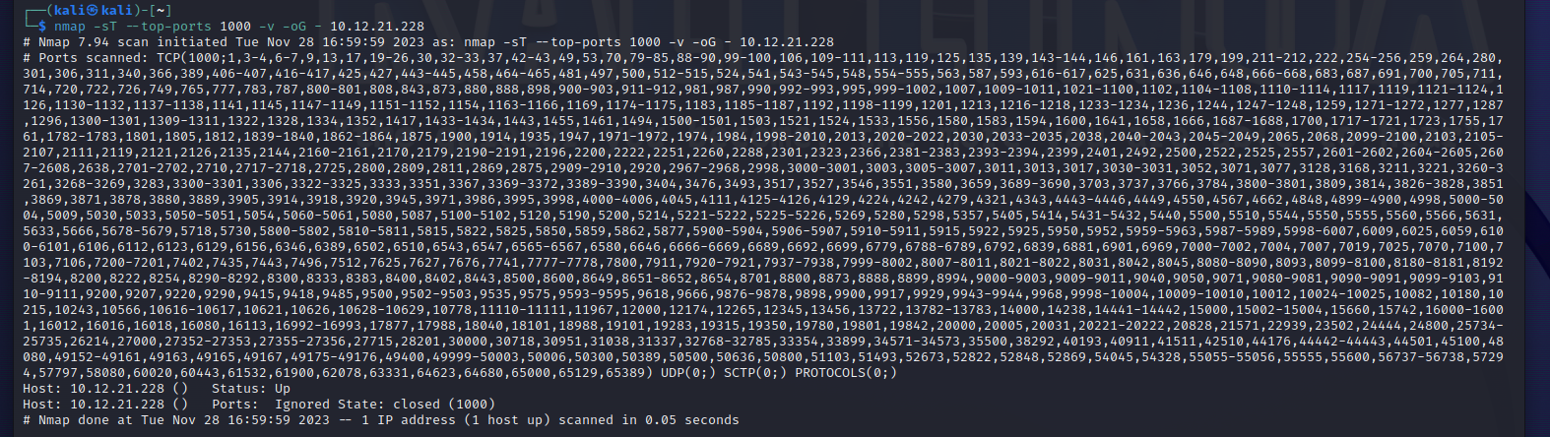

* ~~Perform an intense scan on all hosts on the network.~~
  + First Host (pfsense) 10.12.20.1

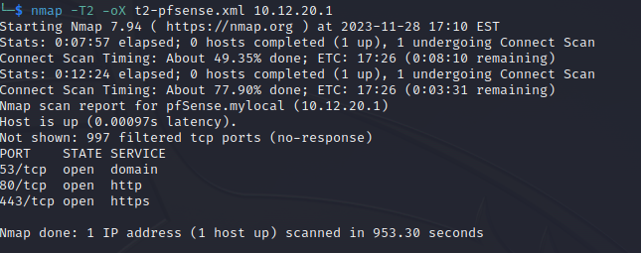

* + Second Host (Windows) 10.12.21.40

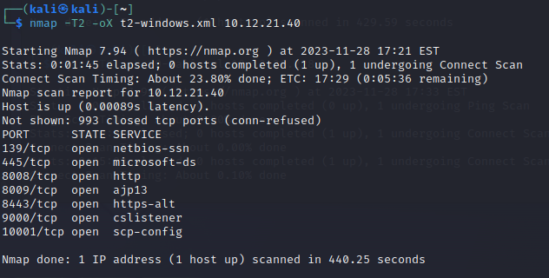

* + Third Host (proxmox) 10.12.20.200

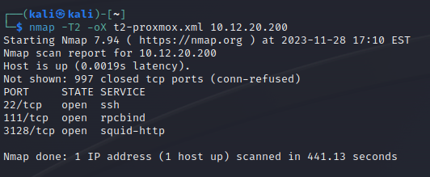

* + Fourth Host (Kali) 10.12.21.228

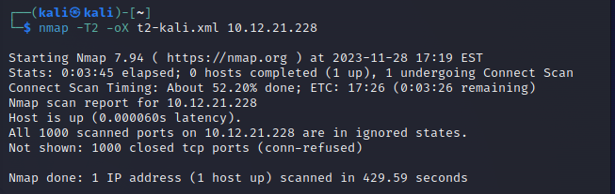

* Perform a slow, comprehensive scan on all hosts on the network.
  + First Host (pfsense) 10.12.20.1

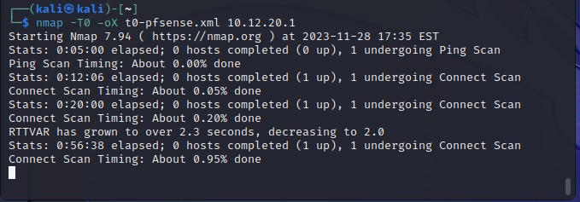

* + Second Host (Windows) 10.12.21.40

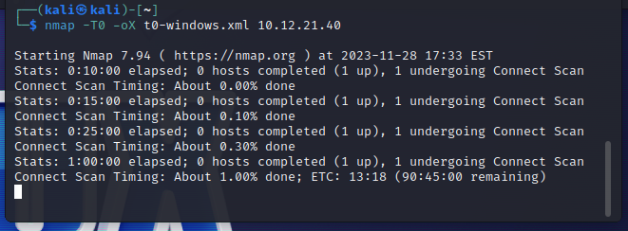

* + Third Host (proxmox) 10.12.20.200

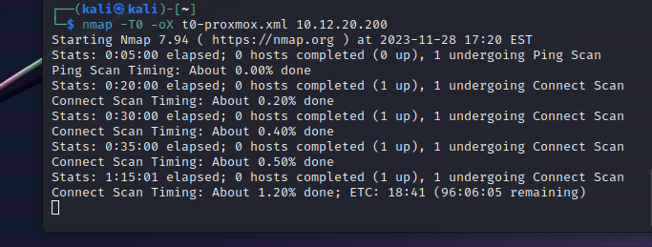

* + Fourth Host (Kali) 10.12.21.228

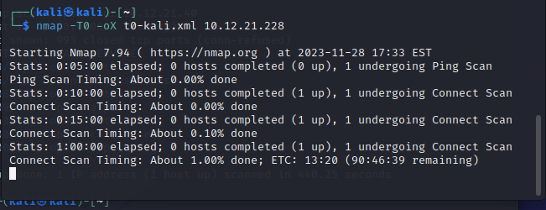

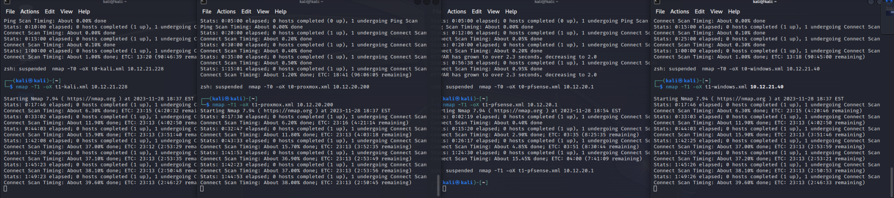

**My VM crashed, this is as far as I got. As you can see, they were all expected to finish at 11PM, I was going to let them run, but that failed.**

*If your local target is yielding inadequate results, try changing your Kali VM’s network settings to Bridged and use* ***nmap*** *to target* ***scanme.nmap.org****, which is a test host provided by Nmap for this very purpose.*

### **Part 3: Reporting Nmap Findings**

Compile your Nmap findings in an organized fashion.

* ~~Create a~~ **~~Scans Performed~~** ~~table with three columns:~~ **~~Scan Type~~**~~,~~ **~~Scan Results~~**~~,~~ **~~Actual~~**~~.~~
  + ~~Populate the table with your results.~~

|  | Scan Type | Scan Results |
| --- | --- | --- |
| 10.12.20.1 pfsense | T4 | Ports: 53/open/tcp//domain///, 80/open/tcp//http///, 443/open/tcp//https///  Ignored State: filtered (997) |
| 10.12.20.200 proxmox | T4 | Ports: 22/open/tcp//ssh///, 111/open/tcp//rpcbind///, 3128/open/tcp//squid-http/// Ignored State: closed (997) |
| 10.12.21.40 windows | T4 | Ports: 139/open/tcp//netbios-ssn///, 445/open/tcp//microsoft-ds///, 8008/open/tcp//http///, 8009/open/tcp//ajp13///, 8443/open/tcp//https-alt///, 9000/open/tcp//cslistener///, 10001/open/tcp//scp-config///  Ignored State: closed (993) |
| 10.12.21.228 Kali | T4 | Ignored State: closed (1000) |
| 10.12.20.1 pfsense | T2 | 53/tcp open domain, 80/tcp open http, 443/tcp open https |
| 10.12.20.200 proxmox | T2 | 22/tcp open ssh, 111/tcp open rpcbind, 3128/tcp open squid-http |
| 10.12.21.40 windows | T2 | 139/tcp open netbios-ssn, 445/tcp open microsoft-ds, 8008/tcp open http, 8009/tcp open ajp13, 8443/tcp open https-alt, 9000/tcp open cslistener, 10001/tcp open scp-config |
| 10.12.21.228 Kali | T2 | All 1000 scanned ports on 10.12.21.228 are in ignored states. |
| 10.12.20.1 pfsense | T1 | **SEE PART 2** |
| 10.12.20.200 proxmox | T1 | **SEE PART 2** |
| 10.12.21.40 windows | T1 | **SEE PART 2** |
| 10.12.21.228 Kali | T1 | **SEE PART 2** |
| Entire Network | -sn | Nmap scan report for pfSense.mylocal (10.12.20.1)  Host is up (0.00021s latency).  MAC Address: 60:BE:B4:04:53:E1 (S-Bluetech, limited)  Nmap scan report for 10.12.20.200  Host is up (0.00028s latency).  MAC Address: 7C:83:34:BD:57:85 (Shenzhen AZW Technology)  Nmap scan report for 10.12.21.40  Host is up (0.00059s latency).  MAC Address: 48:B0:2D:64:D7:84 (Nvidia)  Nmap scan report for 10.12.21.120  Host is up (0.00023s latency).  MAC Address: 3C:7C:3F:1D:E8:81 (ASUSTek Computer)  Nmap scan report for 10.12.21.228  Host is up. |
| pfsense | sT | PORT STATE SERVICE  53/tcp open domain  80/tcp open http  443/tcp open https |
| proxmox | sT | PORT STATE SERVICE  22/tcp open ssh  111/tcp open rpcbind  3128/tcp open squid-http |
| windows | sT | PORT STATE SERVICE  139/tcp open netbios-ssn  445/tcp open microsoft-ds  8008/tcp open http  8009/tcp open ajp13  8443/tcp open https-alt  9000/tcp open cslistener  10001/tcp open scp-config |
| kali | sT | Not shown: 1000 closed tcp ports (conn-refused) |

* ~~Create a~~ **~~Service Enumeration~~** ~~table with three columns:~~ **~~Server IP Address~~**~~,~~ **~~Ports Open~~**~~, and~~ **~~Service/Banner~~**~~.~~
  + ~~Populate the table with your results.~~
  + ~~Indicate above the table your network range with CIDR block notation.~~

| Server IP Address (10.12.20.0/23) | Ports Open | Service/Banner |
| --- | --- | --- |
| 10.12.20.1 | 53  80  443 | Domain  Http  https |
| 10.12.20.200 | 22  111  3128 | ssh  rpcbind  squid-http |
| 10.12.21.40 | 139  445  8008  8009  8443  9000  10001 | Netbios  Microsoft-ds  Http  Ajp13  Https-alt  Cslistener  scp-config |
| 10.12.21.228 | None | None |

***FOR EXAMPLE:***

*Network Range: 192.168.1.0/24 | Server IP Address | Ports Open | Service/Banner |*

*| 192.168.1.1 | 52 | domain | | | 80 | http | |*

*192.168.1.11 | 22 | ssh | | | 25 | smtp |*

### **Part 4: Protocol Hierarchy Statistics with Wireshark**

Let’s explore some protocol-related capabilities of Wireshark in Kali Linux.

* ~~In Wireshark, generate a Protocol Hierarchy Statistics report. Include a screenshot.~~

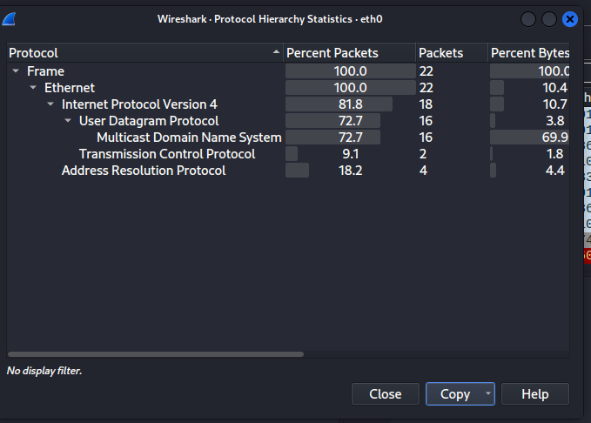

"Protocol","Percent Packets","Packets","Percent Bytes","Bytes","Bits/s","End Packets","End Bytes","End Bits/s","PDUs"

"Frame",100,22,100,3353,2525.1367431623885,0,0,0,22

"Ethernet",100,22,10.438413361169102,350,263.5842111860531,0,0,0,22

"Internet Protocol Version 4",81.81818181818181,18,10.736653742916792,360,271.1151886485117,0,0,0,18

"User Datagram Protocol",72.72727272727273,16,3.8174768863704145,128,96.39651151947083,0,0,0,16

"Multicast Domain Name System",72.72727272727273,16,69.87772144348345,2343,1764.508019454064,16,2343,1764.508019454064,16

"Transmission Control Protocol",9.090909090909092,2,1.7894422904861318,60,45.185864774751956,2,60,45.185864774751956,2

"Address Resolution Protocol",18.181818181818183,4,4.413957649865792,148,111.45846644438816,4,148,111.45846644438816,4

* ~~Which hosts are the top talkers and listeners on this link? Check the~~ **~~Statistics > Endpoints~~** ~~menu.~~
  + The biggest talkers (transmitters) (one of my Windows PCs that just came on)

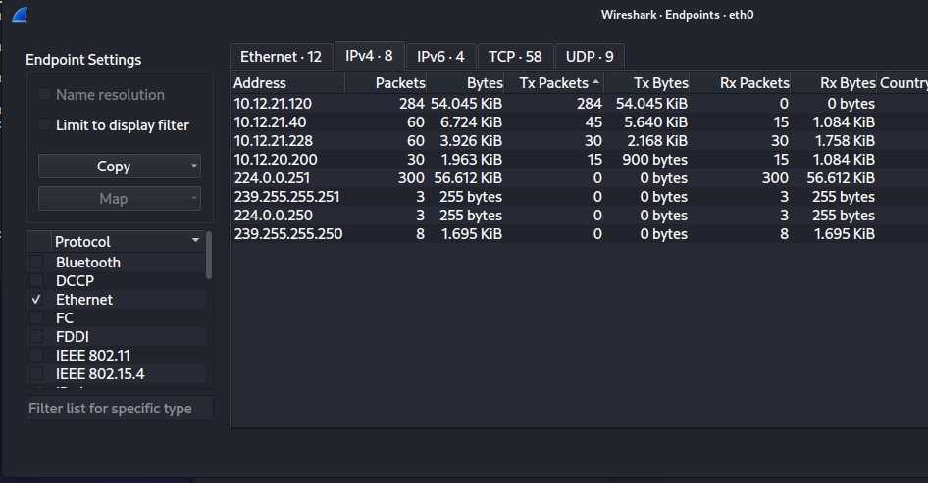

* The biggest listeners (recievers) I have no idea yet who 224.0.0.251 is, but he MUST be stopped, the second highest is my VM

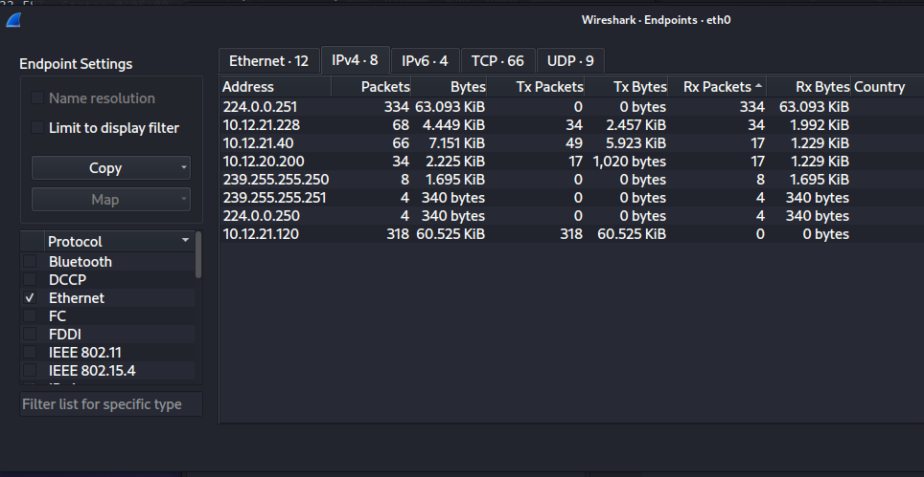

* Select Close and then select **Statistics > Conversations**. Sort this by session duration and include a screenshot.

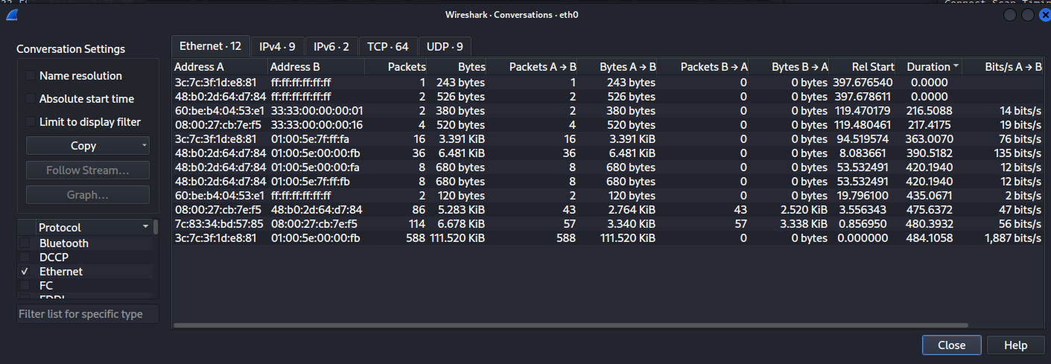

### **Part 5: Netstat**

**Netstat** can reveal port and service information on a Windows host. Include screenshots (or copied text) of your entered command and the output for the following on a Windows VM:

* ~~From a terminal prompt, run a~~ **~~netstat~~** ~~command that shows all active ports.~~

┌──(kali㉿kali)-[~]

└─$ netstat -a

Active Internet connections (servers and established)

Proto Recv-Q Send-Q Local Address Foreign Address State

udp 0 0 10.12.21.228:bootpc pfSense.mylocal:bootps ESTABLISHED

udp6 0 0 fe80::83e:dhcpv6-client [::]:*

raw 0 0 0.0.0.0:255 0.0.0.0:* 7

raw 0 0 0.0.0.0:255 0.0.0.0:* 7

raw6 0 0 [::]:ipv6-icmp [::]:* 7

Active UNIX domain sockets (servers and established)

Proto RefCnt Flags Type State I-Node Path

unix 3 [ ] STREAM CONNECTED 19369 /run/systemd/journal/stdout

unix 3 [ ] STREAM CONNECTED 158308 @/tmp/.X11-unix/X0

unix 3 [ ] STREAM CONNECTED 20942

unix 3 [ ] STREAM CONNECTED 19086

unix 3 [ ] STREAM CONNECTED 155457 /run/user/1000/bus

unix 3 [ ] STREAM CONNECTED 140754 /run/systemd/journal/stdout

unix 3 [ ] STREAM CONNECTED 31412

unix 3 [ ] STREAM CONNECTED 20531 @/tmp/.X11-unix/X0

unix 3 [ ] STREAM CONNECTED 20005

unix 3 [ ] STREAM CONNECTED 19805

unix 3 [ ] STREAM CONNECTED 20166 @/tmp/.X11-unix/X0

unix 3 [ ] STREAM CONNECTED 20097 /run/dbus/system_bus_socket

unix 3 [ ] STREAM CONNECTED 19198 /run/dbus/system_bus_socket

unix 3 [ ] STREAM CONNECTED 71618

unix 3 [ ] STREAM CONNECTED 19433 @/tmp/.X11-unix/X0

unix 3 [ ] STREAM CONNECTED 20040

unix 3 [ ] STREAM CONNECTED 20586 @/tmp/.X11-unix/X0

unix 3 [ ] STREAM CONNECTED 19856

unix 3 [ ] STREAM CONNECTED 19480

unix 3 [ ] STREAM CONNECTED 20174

unix 3 [ ] STREAM CONNECTED 20665 /run/user/1000/bus

unix 3 [ ] STREAM CONNECTED 19914 @/tmp/.X11-unix/X0

unix 2 [ ACC ] STREAM LISTENING 18472 /tmp/.X11-unix/X0

unix 3 [ ] STREAM CONNECTED 20508

unix 3 [ ] STREAM CONNECTED 20846 /run/user/1000/bus

unix 3 [ ] STREAM CONNECTED 19973

unix 3 [ ] STREAM CONNECTED 19270 /run/user/1000/bus

unix 3 [ ] DGRAM CONNECTED 18195

unix 3 [ ] STREAM CONNECTED 16235

unix 3 [ ] STREAM CONNECTED 17360

unix 3 [ ] STREAM CONNECTED 157226 /run/user/1000/at-spi/bus_0

unix 3 [ ] STREAM CONNECTED 80111 /run/systemd/journal/stdout

unix 3 [ ] STREAM CONNECTED 19894 @/tmp/.X11-unix/X0

unix 2 [ ACC ] STREAM LISTENING 19638 /tmp/ssh-qpVVXNrj3H9o/agent.896

unix 3 [ ] STREAM CONNECTED 80084

unix 3 [ ] STREAM CONNECTED 19365

unix 3 [ ] STREAM CONNECTED 20734 /run/dbus/system_bus_socket

unix 3 [ ] STREAM CONNECTED 16175

unix 3 [ ] STREAM CONNECTED 120055

unix 3 [ ] STREAM CONNECTED 20537 /run/user/1000/pipewire-0

unix 3 [ ] STREAM CONNECTED 154503 @/tmp/.X11-unix/X0

unix 3 [ ] STREAM CONNECTED 140757

unix 3 [ ] STREAM CONNECTED 19468

unix 3 [ ] STREAM CONNECTED 19353 /run/systemd/journal/stdout

unix 2 [ ACC ] STREAM LISTENING 19322 /tmp/.ICE-unix/896

unix 3 [ ] STREAM CONNECTED 18997 /run/systemd/journal/stdout

unix 3 [ ] STREAM CONNECTED 20020

unix 2 [ ] DGRAM CONNECTED 19652

unix 3 [ ] STREAM CONNECTED 20974

unix 3 [ ] STREAM CONNECTED 19443 @/tmp/.X11-unix/X0

unix 3 [ ] STREAM CONNECTED 19702

unix 3 [ ] STREAM CONNECTED 20523

unix 3 [ ] STREAM CONNECTED 20512 /run/user/1000/pulse/native

unix 3 [ ] STREAM CONNECTED 71624 @/tmp/.ICE-unix/896

unix 3 [ ] STREAM CONNECTED 21002 @/tmp/.X11-unix/X0

unix 3 [ ] STREAM CONNECTED 20624

unix 3 [ ] STREAM CONNECTED 19507

unix 2 [ ] DGRAM 20060

unix 3 [ ] STREAM CONNECTED 20841

unix 3 [ ] STREAM CONNECTED 20583 @/tmp/.X11-unix/X0

unix 3 [ ] STREAM CONNECTED 19269

unix 3 [ ] STREAM CONNECTED 158315

unix 3 [ ] STREAM CONNECTED 79261 @/tmp/.X11-unix/X0

unix 3 [ ] STREAM CONNECTED 78814

unix 3 [ ] DGRAM CONNECTED 15739

unix 3 [ ] STREAM CONNECTED 158314

unix 3 [ ] STREAM CONNECTED 31413 /run/user/1000/at-spi/bus_0

unix 3 [ ] STREAM CONNECTED 158313 @/tmp/.ICE-unix/896

unix 3 [ ] STREAM CONNECTED 154508

unix 3 [ ] STREAM CONNECTED 19056 /run/systemd/journal/stdout

unix 3 [ ] STREAM CONNECTED 20938 /run/systemd/journal/stdout

unix 3 [ ] STREAM CONNECTED 19806 @/tmp/.X11-unix/X0

unix 3 [ ] STREAM CONNECTED 16161

unix 3 [ ] STREAM CONNECTED 32125

unix 3 [ ] STREAM CONNECTED 19703 /run/user/1000/bus

unix 3 [ ] STREAM CONNECTED 79241

unix 3 [ ] STREAM CONNECTED 19440 /run/user/1000/bus

unix 3 [ ] STREAM CONNECTED 19666

unix 2 [ ] DGRAM CONNECTED 18277

unix 3 [ ] STREAM CONNECTED 19813

unix 3 [ ] STREAM CONNECTED 20007 /run/user/1000/bus

unix 3 [ ] STREAM CONNECTED 20502 /run/user/1000/at-spi/bus_0

unix 3 [ ] STREAM CONNECTED 32123 @/tmp/.X11-unix/X0

unix 3 [ ] STREAM CONNECTED 20056

unix 3 [ ] STREAM CONNECTED 20571 /run/dbus/system_bus_socket

unix 3 [ ] STREAM CONNECTED 19913

unix 3 [ ] STREAM CONNECTED 19873

unix 3 [ ] STREAM CONNECTED 17570 /run/systemd/journal/stdout

unix 3 [ ] STREAM CONNECTED 19981 /run/systemd/journal/stdout

unix 3 [ ] STREAM CONNECTED 19494 /run/user/1000/bus

unix 3 [ ] STREAM CONNECTED 20481

unix 3 [ ] STREAM CONNECTED 80122 /run/user/1000/bus

unix 3 [ ] STREAM CONNECTED 19075

unix 3 [ ] STREAM CONNECTED 20903

unix 3 [ ] STREAM CONNECTED 72530 @/tmp/.X11-unix/X0

unix 3 [ ] STREAM CONNECTED 20886

unix 3 [ ] STREAM CONNECTED 19225

unix 3 [ ] STREAM CONNECTED 154506

unix 3 [ ] STREAM CONNECTED 158094 /run/user/1000/bus

unix 3 [ ] STREAM CONNECTED 140749

unix 3 [ ] STREAM CONNECTED 19928

unix 3 [ ] STREAM CONNECTED 19658 /run/user/1000/bus

unix 3 [ ] STREAM CONNECTED 18425

unix 3 [ ] STREAM CONNECTED 79232 /run/user/1000/bus

unix 3 [ ] STREAM CONNECTED 20042 /run/dbus/system_bus_socket

unix 3 [ ] STREAM CONNECTED 19757 /run/user/1000/bus

unix 3 [ ] STREAM CONNECTED 115429 /run/user/1000/at-spi/bus_0

unix 3 [ ] STREAM CONNECTED 19836

unix 3 [ ] STREAM CONNECTED 19701 @/tmp/.X11-unix/X0

unix 3 [ ] STREAM CONNECTED 20009 /run/dbus/system_bus_socket

unix 3 [ ] STREAM CONNECTED 19800 @/tmp/.X11-unix/X0

unix 3 [ ] STREAM CONNECTED 18950 /run/dbus/system_bus_socket

unix 2 [ ] DGRAM CONNECTED 20961

unix 3 [ ] STREAM CONNECTED 17433 /run/systemd/journal/stdout

unix 3 [ ] STREAM CONNECTED 20507

unix 2 [ ] DGRAM CONNECTED 17725

unix 3 [ ] STREAM CONNECTED 20171

unix 3 [ ] STREAM CONNECTED 20525

unix 3 [ ] STREAM CONNECTED 18474

unix 3 [ ] STREAM CONNECTED 20937

unix 3 [ ] STREAM CONNECTED 20041

unix 3 [ ] STREAM CONNECTED 19924

unix 3 [ ] STREAM CONNECTED 19850

unix 3 [ ] STREAM CONNECTED 115426

unix 3 [ ] STREAM CONNECTED 80129 /run/user/1000/pipewire-0

unix 3 [ ] STREAM CONNECTED 20527 /run/user/1000/bus

unix 3 [ ] STREAM CONNECTED 19506

unix 3 [ ] DGRAM CONNECTED 2000

unix 3 [ ] STREAM CONNECTED 15762 /run/systemd/journal/stdout

unix 3 [ ] STREAM CONNECTED 20842 /run/user/1000/at-spi/bus_0

unix 3 [ ] STREAM CONNECTED 19974

unix 3 [ ] STREAM CONNECTED 19816

unix 2 [ ] DGRAM 18358 /run/user/1000/systemd/notify

unix 3 [ ] STREAM CONNECTED 17542 /run/dbus/system_bus_socket

unix 3 [ ] STREAM CONNECTED 20870 /run/systemd/journal/stdout

unix 2 [ ACC ] STREAM LISTENING 18361 /run/user/1000/systemd/private

unix 3 [ ] STREAM CONNECTED 20957 /run/systemd/journal/stdout

unix 2 [ ACC ] STREAM LISTENING 18370 /run/user/1000/bus

unix 3 [ ] STREAM CONNECTED 115430

unix 3 [ ] STREAM CONNECTED 71626

unix 3 [ ] STREAM CONNECTED 19438 @/tmp/.ICE-unix/896

unix 3 [ ] DGRAM CONNECTED 15054 /run/systemd/notify

unix 2 [ ACC ] STREAM LISTENING 15057 /run/systemd/private

unix 3 [ ] STREAM CONNECTED 71622

unix 3 [ ] STREAM CONNECTED 19383

unix 2 [ ACC ] STREAM LISTENING 18371 /run/user/1000/gnupg/S.dirmngr

unix 3 [ ] STREAM CONNECTED 16127 /run/systemd/journal/stdout

unix 3 [ ] STREAM CONNECTED 80123 /run/dbus/system_bus_socket

unix 3 [ ] STREAM CONNECTED 19931

unix 2 [ ] DGRAM 18951

unix 2 [ ACC ] STREAM LISTENING 15059 /run/systemd/userdb/io.systemd.DynamicUser

unix 3 [ ] STREAM CONNECTED 154509

unix 3 [ ] STREAM CONNECTED 140755 /run/systemd/journal/stdout

unix 3 [ ] STREAM CONNECTED 19305

unix 3 [ ] STREAM CONNECTED 19055 /run/systemd/journal/stdout

unix 2 [ ACC ] STREAM LISTENING 18373 /run/user/1000/gcr/ssh

unix 2 [ ACC ] STREAM LISTENING 15060 /run/systemd/io.system.ManagedOOM

unix 3 [ ] STREAM CONNECTED 74393 @/tmp/.X11-unix/X0

unix 3 [ ] STREAM CONNECTED 20897

unix 3 [ ] STREAM CONNECTED 20605 /run/dbus/system_bus_socket

unix 3 [ ] STREAM CONNECTED 19408

unix 2 [ ACC ] STREAM LISTENING 18375 /run/user/1000/keyring/control

unix 3 [ ] STREAM CONNECTED 1986

unix 3 [ ] STREAM CONNECTED 115989 @/tmp/.X11-unix/X0

unix 2 [ ACC ] STREAM LISTENING 18377 /run/user/1000/gnupg/S.gpg-agent.browser

unix 2 [ ACC ] STREAM LISTENING 1804 /run/systemd/fsck.progress

unix 3 [ ] STREAM CONNECTED 80120 /run/user/1000/at-spi/bus_0

unix 3 [ ] STREAM CONNECTED 80078

unix 3 [ ] STREAM CONNECTED 20578 @/tmp/.X11-unix/X0

unix 2 [ ACC ] STREAM LISTENING 18379 /run/user/1000/gnupg/S.gpg-agent.extra

unix 3 [ ] STREAM CONNECTED 20640

unix 3 [ ] STREAM CONNECTED 20522 /run/user/1000/at-spi/bus_0

unix 3 [ ] STREAM CONNECTED 19881

unix 2 [ ACC ] STREAM LISTENING 18381 /run/user/1000/gnupg/S.gpg-agent.ssh

unix 3 [ ] STREAM CONNECTED 157221

unix 3 [ ] STREAM CONNECTED 72534

unix 3 [ ] STREAM CONNECTED 20680 /run/user/1000/bus

unix 3 [ ] STREAM CONNECTED 19885 @/tmp/.X11-unix/X0

unix 2 [ ACC ] STREAM LISTENING 18383 /run/user/1000/gnupg/S.gpg-agent

unix 13 [ ] DGRAM CONNECTED 1805 /run/systemd/journal/dev-log

unix 3 [ ] STREAM CONNECTED 20509 /run/user/1000/at-spi/bus_0

unix 6 [ ] DGRAM CONNECTED 1807 /run/systemd/journal/socket

unix 2 [ ACC ] STREAM LISTENING 18385 /run/user/1000/pulse/native

unix 2 [ ACC ] STREAM LISTENING 1809 /run/systemd/journal/stdout

unix 3 [ ] STREAM CONNECTED 20633 /run/user/1000/at-spi/bus_0

unix 3 [ ] STREAM CONNECTED 19431 @/tmp/.ICE-unix/896

unix 2 [ ACC ] STREAM LISTENING 18387 /run/user/1000/pipewire-0

unix 2 [ ACC ] SEQPACKET LISTENING 1811 /run/udev/control

unix 3 [ ] STREAM CONNECTED 73448

unix 3 [ ] STREAM CONNECTED 21004

unix 3 [ ] STREAM CONNECTED 19847 @/tmp/.ICE-unix/896

unix 3 [ ] DGRAM CONNECTED 18359

unix 3 [ ] STREAM CONNECTED 20675

unix 3 [ ] STREAM CONNECTED 80085 /run/systemd/journal/stdout

unix 3 [ ] STREAM CONNECTED 19752 /run/user/1000/bus

unix 3 [ ] STREAM CONNECTED 157004

unix 2 [ ] DGRAM CONNECTED 16164

unix 3 [ ] STREAM CONNECTED 158312

unix 3 [ ] STREAM CONNECTED 155456 @/tmp/.ICE-unix/896

unix 3 [ ] STREAM CONNECTED 32126 /run/user/1000/bus

unix 3 [ ] STREAM CONNECTED 72532 @/tmp/.X11-unix/X0

unix 3 [ ] STREAM CONNECTED 20892

unix 2 [ ] DGRAM 17799

unix 3 [ ] STREAM CONNECTED 19972

unix 3 [ ] STREAM CONNECTED 19648 @/tmp/.X11-unix/X0

unix 3 [ ] STREAM CONNECTED 19447 /run/user/1000/at-spi/bus_0

unix 3 [ ] STREAM CONNECTED 78815 /run/user/1000/gvfsd/socket-GmGh8SCm

unix 2 [ ACC ] STREAM LISTENING 19502 /run/user/1000/keyring/pkcs11

unix 3 [ ] STREAM CONNECTED 80068

unix 3 [ ] STREAM CONNECTED 20826 @/tmp/.X11-unix/X0

unix 3 [ ] STREAM CONNECTED 20645 @/tmp/.ICE-unix/896

unix 3 [ ] STREAM CONNECTED 20599

unix 3 [ ] STREAM CONNECTED 19891 /run/user/1000/at-spi/bus_0

unix 3 [ ] STREAM CONNECTED 19860 @/tmp/.X11-unix/X0

unix 3 [ ] STREAM CONNECTED 17565

unix 3 [ ] STREAM CONNECTED 19488

unix 3 [ ] STREAM CONNECTED 20498

unix 3 [ ] STREAM CONNECTED 74398 @/tmp/.ICE-unix/896

unix 3 [ ] STREAM CONNECTED 19837

unix 3 [ ] STREAM CONNECTED 20971

unix 3 [ ] STREAM CONNECTED 20117

unix 2 [ ACC ] STREAM LISTENING 19302 /run/user/1000/at-spi/bus_0

unix 3 [ ] STREAM CONNECTED 19510

unix 3 [ ] STREAM CONNECTED 20091

unix 3 [ ] STREAM CONNECTED 19799

unix 3 [ ] STREAM CONNECTED 19048 /run/dbus/system_bus_socket

unix 3 [ ] STREAM CONNECTED 121675

unix 3 [ ] STREAM CONNECTED 80125 /run/dbus/system_bus_socket

unix 3 [ ] STREAM CONNECTED 18421

unix 2 [ ACC ] STREAM LISTENING 1860 /run/systemd/journal/io.systemd.journal

unix 3 [ ] STREAM CONNECTED 19936 /run/dbus/system_bus_socket

unix 3 [ ] STREAM CONNECTED 19307

unix 3 [ ] STREAM CONNECTED 19104 /run/dbus/system_bus_socket

unix 3 [ ] STREAM CONNECTED 20703

unix 3 [ ] STREAM CONNECTED 16188 /run/dbus/system_bus_socket

unix 3 [ ] STREAM CONNECTED 19453 /run/user/1000/bus

unix 3 [ ] STREAM CONNECTED 18011 @/tmp/.X11-unix/X0

unix 2 [ ] DGRAM CONNECTED 15733

unix 3 [ ] STREAM CONNECTED 20073 /run/dbus/system_bus_socket

unix 3 [ ] STREAM CONNECTED 19279 /run/systemd/journal/stdout

unix 3 [ ] STREAM CONNECTED 17539

unix 3 [ ] STREAM CONNECTED 20608 /run/user/1000/bus

unix 2 [ ] DGRAM CONNECTED 1863

unix 3 [ ] STREAM CONNECTED 73445

unix 3 [ ] STREAM CONNECTED 20529

unix 3 [ ] STREAM CONNECTED 19920 /run/systemd/journal/stdout

unix 3 [ ] STREAM CONNECTED 20489 /run/user/1000/at-spi/bus_0

unix 3 [ ] STREAM CONNECTED 19175 /run/user/1000/pipewire-0

unix 3 [ ] STREAM CONNECTED 20098

unix 3 [ ] STREAM CONNECTED 115993 /run/user/1000/at-spi/bus_0

unix 3 [ ] STREAM CONNECTED 20173 @/tmp/.ICE-unix/896

unix 3 [ ] STREAM CONNECTED 19845

unix 3 [ ] DGRAM CONNECTED 15055

unix 3 [ ] STREAM CONNECTED 20871 /run/user/1000/bus

unix 3 [ ] STREAM CONNECTED 19404 /run/user/1000/at-spi/bus_0

unix 2 [ ] DGRAM 19512

unix 3 [ ] STREAM CONNECTED 19941 @/tmp/.ICE-unix/896

unix 3 [ ] STREAM CONNECTED 18700

unix 2 [ ] DGRAM CONNECTED 121674

unix 3 [ ] STREAM CONNECTED 19828

unix 2 [ ] DGRAM CONNECTED 120045

unix 3 [ ] STREAM CONNECTED 80079 /run/systemd/journal/stdout

unix 3 [ ] STREAM CONNECTED 20943 /run/user/1000/bus

unix 3 [ ] STREAM CONNECTED 16187

unix 3 [ ] STREAM CONNECTED 80116

unix 3 [ ] STREAM CONNECTED 20485

unix 3 [ ] STREAM CONNECTED 19076 /run/systemd/journal/stdout

unix 2 [ ] DGRAM CONNECTED 17374

unix 3 [ ] STREAM CONNECTED 20904 /run/systemd/journal/stdout

unix 3 [ ] STREAM CONNECTED 20876

unix 3 [ ] STREAM CONNECTED 19248 @/tmp/.X11-unix/X0

unix 3 [ ] STREAM CONNECTED 15973

unix 3 [ ] STREAM CONNECTED 20504 /run/user/1000/bus

unix 3 [ ] STREAM CONNECTED 20914 /run/user/1000/bus

unix 3 [ ] STREAM CONNECTED 20607

unix 3 [ ] STREAM CONNECTED 21005 /run/user/1000/bus

unix 3 [ ] STREAM CONNECTED 20913

unix 3 [ ] STREAM CONNECTED 19902

unix 3 [ ] STREAM CONNECTED 19875

unix 3 [ ] STREAM CONNECTED 19498

unix 3 [ ] STREAM CONNECTED 17575 /run/dbus/system_bus_socket

unix 3 [ ] STREAM CONNECTED 20172 /run/user/1000/at-spi/bus_0

unix 3 [ ] STREAM CONNECTED 20070

unix 3 [ ] STREAM CONNECTED 19882

unix 3 [ ] STREAM CONNECTED 18475 /run/dbus/system_bus_socket

unix 3 [ ] STREAM CONNECTED 19995 /run/dbus/system_bus_socket

unix 3 [ ] STREAM CONNECTED 20570

unix 3 [ ] STREAM CONNECTED 19097 /run/dbus/system_bus_socket

unix 3 [ ] STREAM CONNECTED 20499 /run/user/1000/bus

unix 3 [ ] STREAM CONNECTED 19970

unix 3 [ ] STREAM CONNECTED 19627 @/tmp/.X11-unix/X0

unix 3 [ ] STREAM CONNECTED 15702 /run/systemd/journal/stdout

unix 3 [ ] STREAM CONNECTED 20765

unix 3 [ ] STREAM CONNECTED 19452

unix 3 [ ] STREAM CONNECTED 19081 /run/systemd/journal/stdout

unix 3 [ ] DGRAM CONNECTED 15738

unix 3 [ ] STREAM CONNECTED 19366 /run/user/1000/at-spi/bus_0

unix 3 [ ] STREAM CONNECTED 20722

unix 3 [ ] STREAM CONNECTED 19109

unix 3 [ ] STREAM CONNECTED 157223 /run/user/1000/at-spi/bus_0

unix 3 [ ] STREAM CONNECTED 154511

unix 3 [ ] STREAM CONNECTED 20496

unix 3 [ ] STREAM CONNECTED 19074 /run/systemd/journal/stdout

unix 2 [ ] DGRAM CONNECTED 15492

unix 3 [ ] STREAM CONNECTED 20008

unix 3 [ ] STREAM CONNECTED 18282

unix 3 [ ] STREAM CONNECTED 19399 @/tmp/.ICE-unix/896

unix 3 [ ] STREAM CONNECTED 21007 /run/user/1000/at-spi/bus_0

unix 3 [ ] STREAM CONNECTED 19308 /run/user/1000/bus

unix 3 [ ] STREAM CONNECTED 19087 /run/dbus/system_bus_socket

unix 3 [ ] STREAM CONNECTED 21001

unix 3 [ ] STREAM CONNECTED 20490 /run/user/1000/bus

unix 3 [ ] STREAM CONNECTED 20898 /run/user/1000/bus

unix 3 [ ] STREAM CONNECTED 20642 @/tmp/.X11-unix/X0

unix 3 [ ] STREAM CONNECTED 19903 @/tmp/.X11-unix/X0

unix 3 [ ] STREAM CONNECTED 17574

unix 3 [ ] STREAM CONNECTED 74395 @/tmp/.X11-unix/X0

unix 3 [ ] STREAM CONNECTED 20524 /run/user/1000/bus

unix 3 [ ] STREAM CONNECTED 19859

unix 3 [ ] STREAM CONNECTED 19495

unix 3 [ ] STREAM CONNECTED 19900 /run/user/1000/at-spi/bus_0

unix 3 [ ] STREAM CONNECTED 17734

unix 3 [ ] STREAM CONNECTED 20733

unix 3 [ ] STREAM CONNECTED 19603 @/tmp/.X11-unix/X0

unix 3 [ ] STREAM CONNECTED 115424

unix 2 [ ACC ] STREAM LISTENING 17350 /run/dbus/system_bus_socket

unix 3 [ ] STREAM CONNECTED 80110

unix 3 [ ] STREAM CONNECTED 19446

unix 2 [ ACC ] STREAM LISTENING 17351 /run/pcscd/pcscd.comm

unix 3 [ ] STREAM CONNECTED 20054 /run/systemd/journal/stdout

unix 3 [ ] STREAM CONNECTED 19779 /run/user/1000/bus

unix 3 [ ] STREAM CONNECTED 154510

unix 3 [ ] STREAM CONNECTED 19073 /run/systemd/journal/stdout

unix 3 [ ] STREAM CONNECTED 157224

unix 3 [ ] STREAM CONNECTED 19935

unix 3 [ ] STREAM CONNECTED 18701 /run/systemd/journal/stdout

unix 3 [ ] STREAM CONNECTED 19407 /run/dbus/system_bus_socket

unix 3 [ ] STREAM CONNECTED 20095

unix 3 [ ] STREAM CONNECTED 21006

unix 3 [ ] STREAM CONNECTED 19513

unix 2 [ ] DGRAM CONNECTED 18319

unix 3 [ ] STREAM CONNECTED 80089 /run/user/1000/bus

unix 3 [ ] STREAM CONNECTED 74400 /run/user/1000/at-spi/bus_0

unix 3 [ ] STREAM CONNECTED 19834

unix 2 [ ] DGRAM CONNECTED 17510

unix 3 [ ] STREAM CONNECTED 20501

unix 3 [ ] STREAM CONNECTED 158310 @/tmp/.X11-unix/X0

unix 3 [ ] STREAM CONNECTED 20079

unix 3 [ ] STREAM CONNECTED 20664

unix 3 [ ] STREAM CONNECTED 19479

unix 3 [ ] STREAM CONNECTED 74399

unix 3 [ ] STREAM CONNECTED 20491 /run/user/1000/bus

unix 3 [ ] STREAM CONNECTED 19456 /run/user/1000/at-spi/bus_0

unix 3 [ ] STREAM CONNECTED 115987 @/tmp/.X11-unix/X0

unix 3 [ ] STREAM CONNECTED 19857 @/tmp/.X11-unix/X0

unix 3 [ ] STREAM CONNECTED 20887 /run/user/1000/bus

unix 3 [ ] DGRAM CONNECTED 18194

unix 3 [ ] STREAM CONNECTED 17361 /run/systemd/journal/stdout

unix 3 [ ] STREAM CONNECTED 20594 @/tmp/.X11-unix/X0

unix 3 [ ] STREAM CONNECTED 19278

unix 3 [ ] STREAM CONNECTED 17419 /run/systemd/journal/stdout

unix 3 [ ] STREAM CONNECTED 121676

unix 3 [ ] STREAM CONNECTED 19665 /run/user/1000/at-spi/bus_0

unix 3 [ ] STREAM CONNECTED 115992

unix 3 [ ] STREAM CONNECTED 79265

unix 3 [ ] STREAM CONNECTED 31414 @/tmp/.ICE-unix/896

unix 3 [ ] STREAM CONNECTED 16122

unix 3 [ ] STREAM CONNECTED 19368

unix 3 [ ] STREAM CONNECTED 20923 /run/user/1000/bus

unix 3 [ ] STREAM CONNECTED 19846

unix 3 [ ] STREAM CONNECTED 19511 /run/user/1000/bus

unix 3 [ ] STREAM CONNECTED 115432

unix 3 [ ] STREAM CONNECTED 20956

unix 3 [ ] STREAM CONNECTED 20096

unix 3 [ ] STREAM CONNECTED 19803

unix 3 [ ] STREAM CONNECTED 20497

unix 2 [ ] DGRAM CONNECTED 17577

unix 3 [ ] STREAM CONNECTED 73447

unix 3 [ ] STREAM CONNECTED 20926 /run/user/1000/gvfsd/socket-FUHpY185

unix 3 [ ] STREAM CONNECTED 20677 /run/user/1000/at-spi/bus_0

unix 3 [ ] STREAM CONNECTED 20585

unix 3 [ ] STREAM CONNECTED 19451 /run/user/1000/at-spi/bus_0

unix 3 [ ] STREAM CONNECTED 19496 /run/user/1000/pipewire-0

unix 3 [ ] STREAM CONNECTED 80069 /run/systemd/journal/stdout

unix 3 [ ] STREAM CONNECTED 19884

unix 3 [ ] STREAM CONNECTED 19897 @/tmp/.X11-unix/X0

unix 3 [ ] STREAM CONNECTED 80119

unix 3 [ ] STREAM CONNECTED 19174 /run/user/1000/pipewire-0

unix 3 [ ] STREAM CONNECTED 20763

unix 3 [ ] STREAM CONNECTED 20601 /run/user/1000/bus

unix 3 [ ] STREAM CONNECTED 19247

unix 3 [ ] STREAM CONNECTED 16236 /run/systemd/journal/stdout

unix 3 [ ] STREAM CONNECTED 157005

unix 3 [ ] STREAM CONNECTED 19418

unix 3 [ ] STREAM CONNECTED 19926

unix 3 [ ] STREAM CONNECTED 32127

unix 3 [ ] STREAM CONNECTED 19373

unix 3 [ ] STREAM CONNECTED 157219

unix 2 [ ] DGRAM 110354

unix 3 [ ] STREAM CONNECTED 20676 /run/user/1000/at-spi/bus_0

unix 3 [ ] STREAM CONNECTED 73450

unix 3 [ ] STREAM CONNECTED 19700

unix 2 [ ] DGRAM CONNECTED 18329

unix 3 [ ] STREAM CONNECTED 20975 /run/dbus/system_bus_socket

unix 3 [ ] STREAM CONNECTED 19842

unix 3 [ ] STREAM CONNECTED 19804 @/tmp/.X11-unix/X0

unix 3 [ ] STREAM CONNECTED 17538

unix 3 [ ] STREAM CONNECTED 20012

unix 3 [ ] STREAM CONNECTED 20764 /run/user/1000/bus

unix 3 [ ] STREAM CONNECTED 19984

unix 3 [ ] STREAM CONNECTED 19821 /run/systemd/journal/stdout

unix 3 [ ] STREAM CONNECTED 15761

unix 3 [ ] STREAM CONNECTED 18010

unix 3 [ ] STREAM CONNECTED 19870 @/tmp/.X11-unix/X0

unix 3 [ ] STREAM CONNECTED 19080

unix 3 [ ] STREAM CONNECTED 79228 /run/user/1000/bus

unix 3 [ ] STREAM CONNECTED 20925

unix 3 [ ] STREAM CONNECTED 20530 /run/user/1000/bus

unix 3 [ ] STREAM CONNECTED 19916

unix 3 [ ] STREAM CONNECTED 19493

unix 3 [ ] STREAM CONNECTED 31408

unix 3 [ ] STREAM CONNECTED 20088 /run/user/1000/bus

unix 3 [ ] STREAM CONNECTED 19876 @/tmp/.X11-unix/X0

unix 3 [ ] STREAM CONNECTED 20510

unix 3 [ ] STREAM CONNECTED 19812

unix 3 [ ] STREAM CONNECTED 20016 /run/systemd/journal/stdout

unix 3 [ ] STREAM CONNECTED 72536 /run/user/1000/at-spi/bus_0

unix 3 [ ] STREAM CONNECTED 79240

unix 3 [ ] STREAM CONNECTED 19690

unix 3 [ ] STREAM CONNECTED 19103

unix 3 [ ] DGRAM CONNECTED 18360

unix 3 [ ] STREAM CONNECTED 31416 /run/user/1000/at-spi/bus_0

unix 3 [ ] STREAM CONNECTED 71625

unix 3 [ ] STREAM CONNECTED 19363

unix 3 [ ] STREAM CONNECTED 16178 /run/dbus/system_bus_socket

unix 3 [ ] STREAM CONNECTED 140750

unix 3 [ ] STREAM CONNECTED 19940

unix 3 [ ] STREAM CONNECTED 19419 /run/dbus/system_bus_socket

unix 3 [ ] STREAM CONNECTED 19469

unix 3 [ ] STREAM CONNECTED 120054

unix 3 [ ] STREAM CONNECTED 20845

unix 3 [ ] STREAM CONNECTED 20589 @/tmp/.X11-unix/X0

unix 3 [ ] STREAM CONNECTED 19252

unix 3 [ ] STREAM CONNECTED 71620

unix 3 [ ] STREAM CONNECTED 17555 /run/dbus/system_bus_socket

unix 3 [ ] STREAM CONNECTED 19865 /run/user/1000/bus

unix 3 [ ] STREAM CONNECTED 80121

unix 3 [ ] STREAM CONNECTED 20169

unix 3 [ ] STREAM CONNECTED 20071 /run/dbus/system_bus_socket

unix 3 [ ] STREAM CONNECTED 20486 /run/dbus/system_bus_socket

unix 3 [ ] STREAM CONNECTED 19476 /run/user/1000/bus

unix 3 [ ] STREAM CONNECTED 32121 @/tmp/.X11-unix/X0

unix 3 [ ] STREAM CONNECTED 20628

unix 3 [ ] STREAM CONNECTED 20526 /run/user/1000/at-spi/bus_0

unix 3 [ ] STREAM CONNECTED 19892

unix 3 [ ] STREAM CONNECTED 20503

unix 3 [ ] STREAM CONNECTED 17430

unix 3 [ ] STREAM CONNECTED 20006

unix 3 [ ] STREAM CONNECTED 19437 /run/user/1000/bus

unix 3 [ ] STREAM CONNECTED 115991 @/tmp/.ICE-unix/896

unix 3 [ ] STREAM CONNECTED 74397 /run/user/1000/at-spi/bus_0

unix 3 [ ] STREAM CONNECTED 19367

unix 3 [ ] STREAM CONNECTED 71623 /run/user/1000/at-spi/bus_0

unix 3 [ ] STREAM CONNECTED 19110 /run/user/1000/bus

unix 3 [ ] STREAM CONNECTED 31415

unix 3 [ ] STREAM CONNECTED 20533 /run/user/1000/at-spi/bus_0

unix 3 [ ] STREAM CONNECTED 158091 /run/dbus/system_bus_socket

unix 3 [ ] STREAM CONNECTED 155453 @/tmp/.X11-unix/X0

unix 3 [ ] STREAM CONNECTED 18410

unix 3 [ ] STREAM CONNECTED 80128

unix 3 [ ] STREAM CONNECTED 20494

unix 3 [ ] DGRAM CONNECTED 2001

unix 3 [ ] STREAM CONNECTED 74392

unix 3 [ ] STREAM CONNECTED 20877 /run/systemd/journal/stdout

unix 3 [ ] STREAM CONNECTED 20620 @/tmp/.X11-unix/X0

unix 3 [ ] STREAM CONNECTED 19283

unix 3 [ ] STREAM CONNECTED 19908 @/tmp/.X11-unix/X0

unix 3 [ ] STREAM CONNECTED 73449 /run/user/1000/bus

unix 3 [ ] STREAM CONNECTED 20087

unix 3 [ ] STREAM CONNECTED 20614

unix 3 [ ] STREAM CONNECTED 19890

unix 3 [ ] STREAM CONNECTED 20521

unix 3 [ ] STREAM CONNECTED 19851 @/tmp/.X11-unix/X0

unix 3 [ ] STREAM CONNECTED 19111 /run/user/1000/bus

unix 3 [ ] STREAM CONNECTED 20972 /run/user/1000/bus

unix 3 [ ] STREAM CONNECTED 20116

unix 3 [ ] STREAM CONNECTED 19835 /run/user/1000/at-spi/bus_0

unix 3 [ ] STREAM CONNECTED 19735

unix 3 [ ] STREAM CONNECTED 115431 /run/user/1000/bus

unix 3 [ ] STREAM CONNECTED 157225 /run/user/1000/bus

unix 3 [ ] STREAM CONNECTED 155458 /run/user/1000/at-spi/bus_0

unix 3 [ ] STREAM CONNECTED 79263

unix 3 [ ] STREAM CONNECTED 19127 /run/dbus/system_bus_socket

unix 2 [ ] DGRAM 16174

unix 3 [ ] STREAM CONNECTED 19748 @/tmp/.X11-unix/X0

unix 3 [ ] STREAM CONNECTED 80083

unix 3 [ ] STREAM CONNECTED 20681

unix 3 [ ] STREAM CONNECTED 19454

unix 3 [ ] STREAM CONNECTED 19267

unix 3 [ ] STREAM CONNECTED 20893 /run/systemd/journal/stdout

unix 3 [ ] STREAM CONNECTED 19969

unix 3 [ ] STREAM CONNECTED 17735 /run/dbus/system_bus_socket

unix 2 [ ] DGRAM 20623

unix 3 [ ] STREAM CONNECTED 20511 /run/user/1000/bus

unix 3 [ ] STREAM CONNECTED 80077

unix 3 [ ] STREAM CONNECTED 31410

unix 3 [ ] STREAM CONNECTED 20057 /run/systemd/journal/stdout

unix 3 [ ] STREAM CONNECTED 19099 /run/dbus/system_bus_socket

unix 3 [ ] STREAM CONNECTED 20600 /run/user/1000/at-spi/bus_0

unix 3 [ ] STREAM CONNECTED 19919

unix 3 [ ] STREAM CONNECTED 19864

unix 3 [ ] STREAM CONNECTED 115428

unix 3 [ ] STREAM CONNECTED 79236

unix 3 [ ] STREAM CONNECTED 72535 /run/user/1000/bus

unix 3 [ ] STREAM CONNECTED 19832

unix 3 [ ] STREAM CONNECTED 19691 /run/user/1000/at-spi/bus_0

unix 3 [ ] DGRAM CONNECTED 15056

unix 3 [ ] STREAM CONNECTED 20021 /run/user/1000/bus

unix 3 [ ] STREAM CONNECTED 19405 /run/user/1000/bus

unix 3 [ ] STREAM CONNECTED 18305

unix 3 [ ] STREAM CONNECTED 155452

unix 3 [ ] STREAM CONNECTED 140758 /run/user/1000/bus

unix 3 [ ] STREAM CONNECTED 19304

unix 3 [ ] STREAM CONNECTED 155455 /run/user/1000/at-spi/bus_0

unix 3 [ ] STREAM CONNECTED 19968

unix 3 [ ] STREAM CONNECTED 18403

unix 3 [ ] STREAM CONNECTED 19402

unix 3 [ ] STREAM CONNECTED 17716 /run/dbus/system_bus_socket

unix 3 [ ] STREAM CONNECTED 20724 /run/dbus/system_bus_socket

unix 2 [ ACC ] STREAM LISTENING 18471 @/tmp/.X11-unix/X0

unix 2 [ ACC ] STREAM LISTENING 19321 @/tmp/.ICE-unix/896

unix 3 [ ] STREAM CONNECTED 19473 @c7adf7ec9a4d1980/bus/systemd/bus-api-user

unix 3 [ ] STREAM CONNECTED 17523 @bd9baf3c48ecd1f9/bus/systemd-logind/system

unix 3 [ ] STREAM CONNECTED 17543 @8449bff89fb56fd5/bus/systemd/bus-api-system

unix 3 [ ] STREAM CONNECTED 18362 @47500a8d488d92a4/bus/systemd/bus-system

* ~~Run a~~ **~~netstat~~** ~~command that displays the routing table.~~

Kernel IP routing table

Destination Gateway Genmask Flags MSS Window irtt Iface

default pfSense.mylocal 0.0.0.0 UG 0 0 0 eth0

10.12.20.0 0.0.0.0 255.255.254.0 U 0 0 0 eth0

* ~~Run a~~ **~~netstat~~** ~~command that only displays connections for the TCP protocol.~~

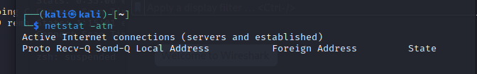

Helpful sources:

<https://www.oreilly.com/library/view/nmap-6-network/9781849517485/ch08s03.html>

<https://nullsec.us/top-1-000-tcp-and-udp-ports-nmap-default/>

<https://chat.openai.com/c/21d8ee83-f7b4-45be-bb50-2779ec959d60>